EDGE INTELLIGENCE LABORATORY
ASSIGNMENT 8

SUBMITTED BY
SHIBU P
25MML0042

On Device Image Recognition

1.Importing Libraries and Checking live video from laptop camera
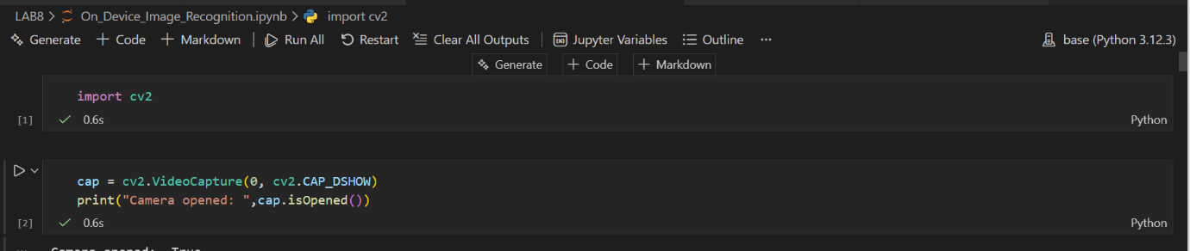

2.Capturing video from Laptop camera
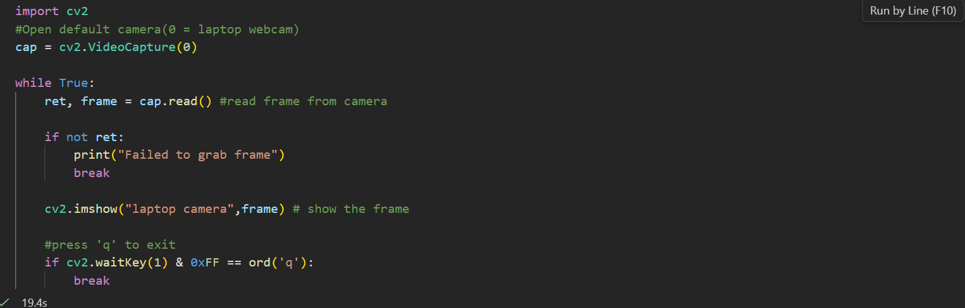

3.Loading sample video from local device

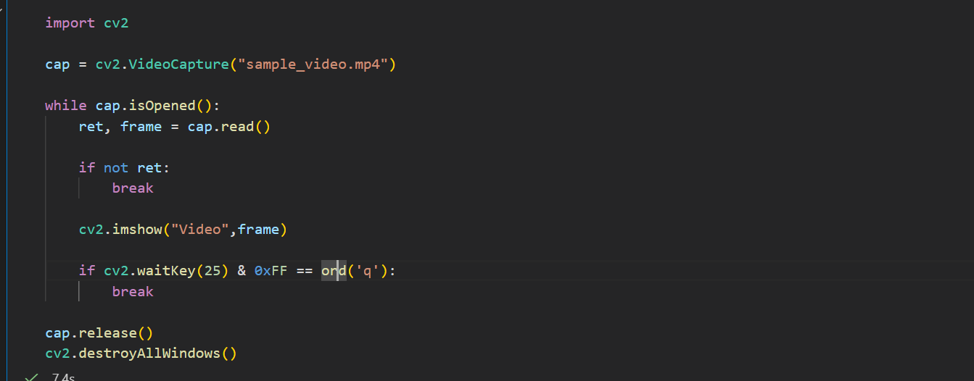

4.Analyzing the sample offline video’s Grayscale ,RGB,Negative,

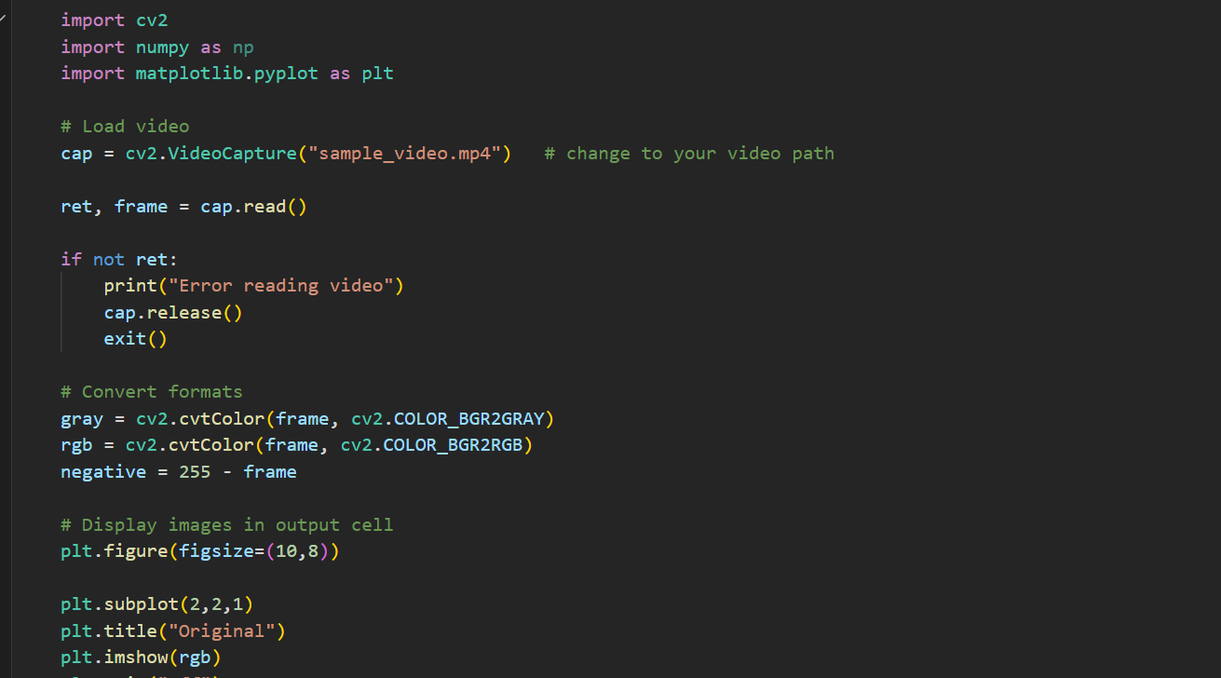

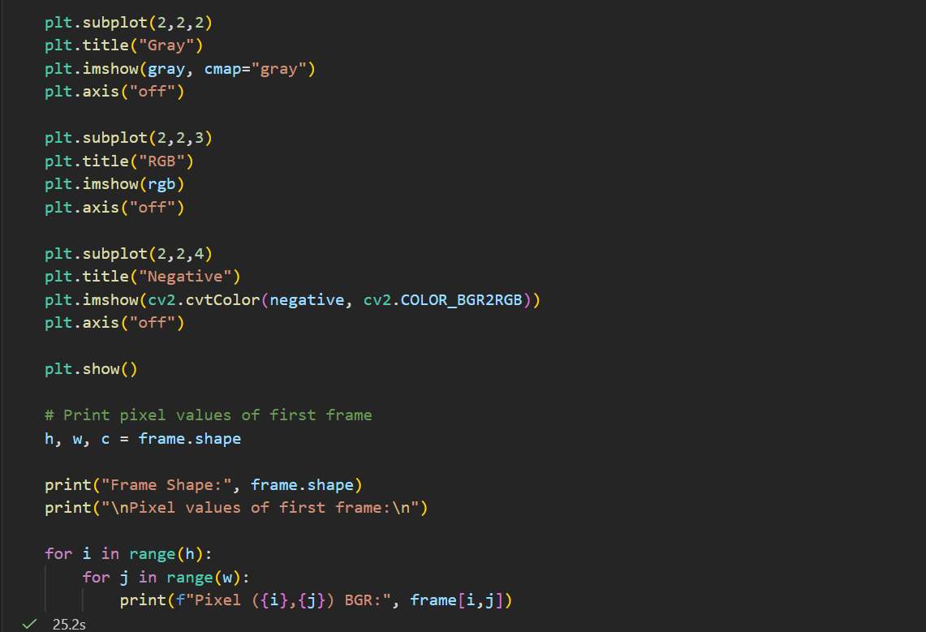

Output:
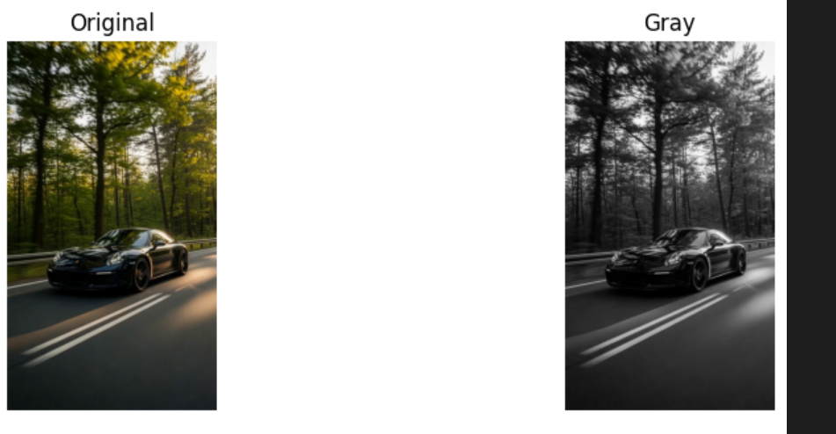

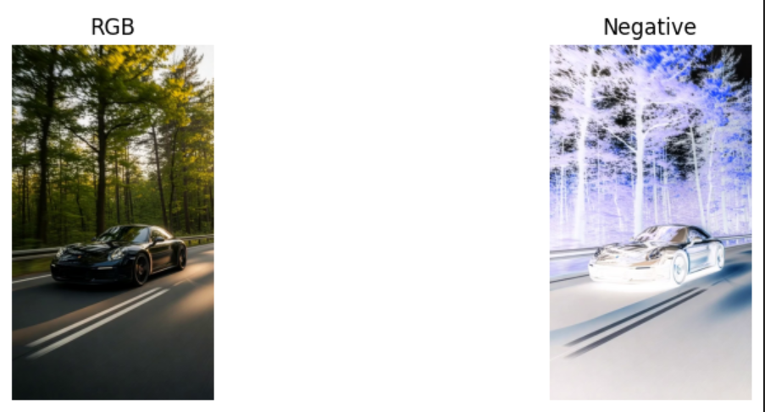

Showing pixel values:
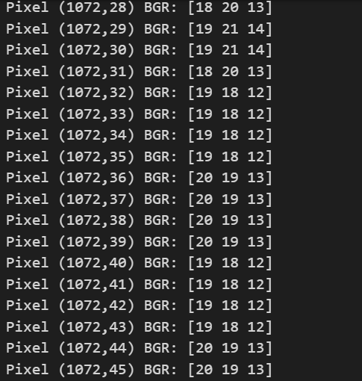

5.Loading Offline sample video and printing total frames of a video,fps,width and height of the frame.
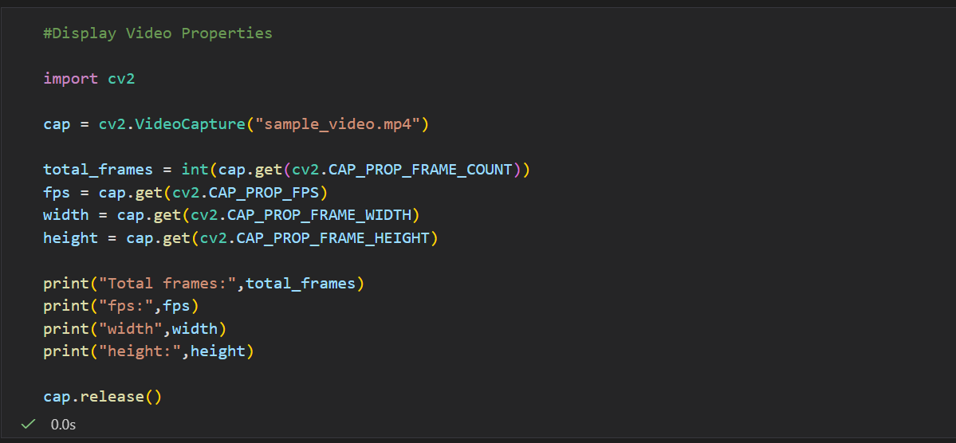

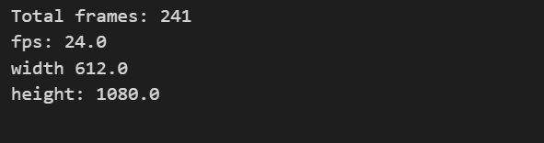

6.Loading video and converting into Grayscale video:

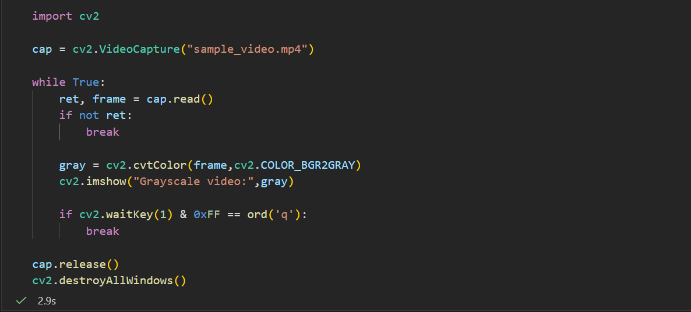

7.Creating Rectangle and circle using opencv
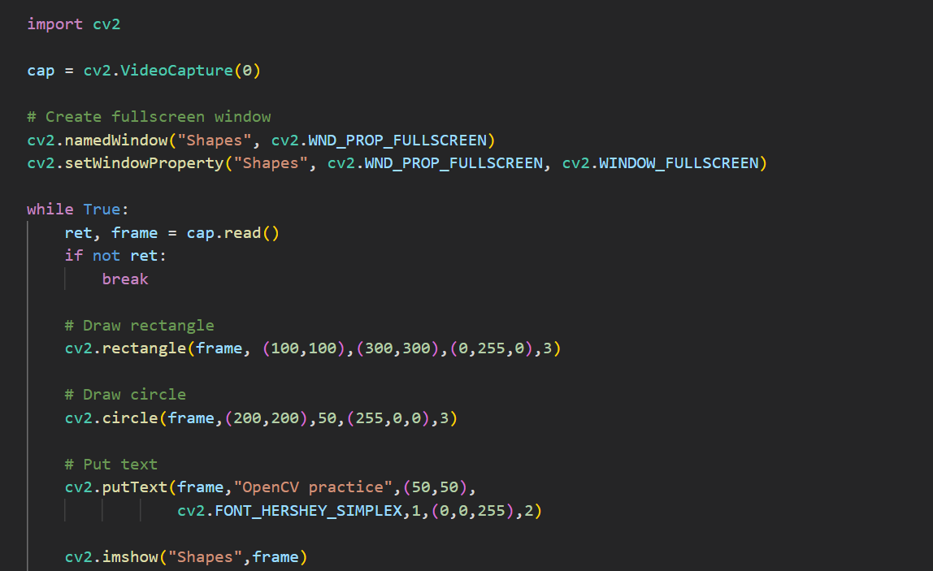

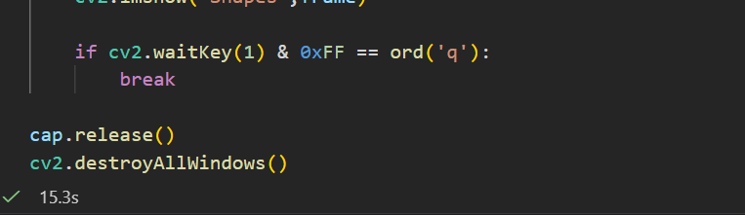

Output:
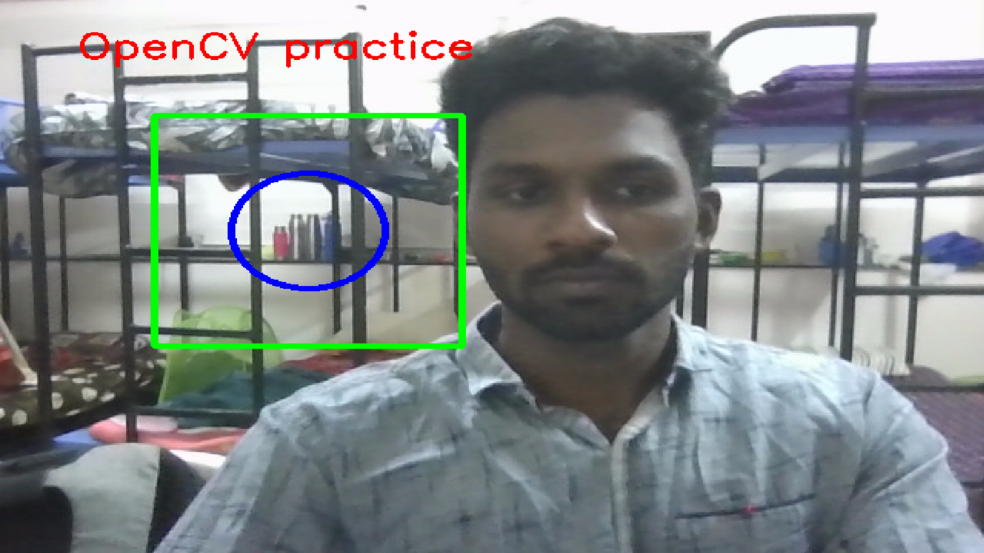

8.Converting live video to find edge using canny operator:

Mathematical Equation:
Step 1: Convert Image to Grayscale
$Gray = 0.299R + 0.587G + 0.114B$
Step 2: Noise Reduction (Gaussian Blur)
$G\left(x,y\right)=\frac{1}{2πσ^{2}}e^{-\frac{x^{2}+y^{2}}{2σ^{2}}}$
The image is convolved with the Gaussian kernel:
$I_{s}\left(x,y\right)=I\left(x,y\right)*G\left(x,y\right)$
Step 3: Compute Image Gradient it finds $G_{x}andG_{y}$

Step 4: Gradient Magnitude (Edge Strength)
$G=\left|G_{x}\right|+\left|G_{y}\right|$

Step 5: Gradient Direction (Edge Orientation)
$θ=\tan^{-1}\left(\frac{G_{y}}{G_{x}}\right)$

$G\left(x,y\right)>T_{H}$

$T_{L}<G\left(x,y\right)<T_{H}$

$G\left(x,y\right)<T_{L}$
Step 6: Non-Maximum Suppression

Steps of Canny Edge Detection :
- Convert the image to grayscale – reduce the image from RGB to a single intensity channel.
- Apply Gaussian blur – smooth the image to remove noise.
- Calculate image gradients – find how quickly the intensity changes in horizontal and vertical directions.
- Compute gradient magnitude and direction – determine the strength and orientation of edges.
- Apply non-maximum suppression – thin the edges by keeping only the strongest pixels.
- Apply double thresholding – classify pixels as strong edges, weak edges, or non-edges.
- Perform edge tracking by hysteresis – keep weak edges that are connected to strong edges and remove the rest.

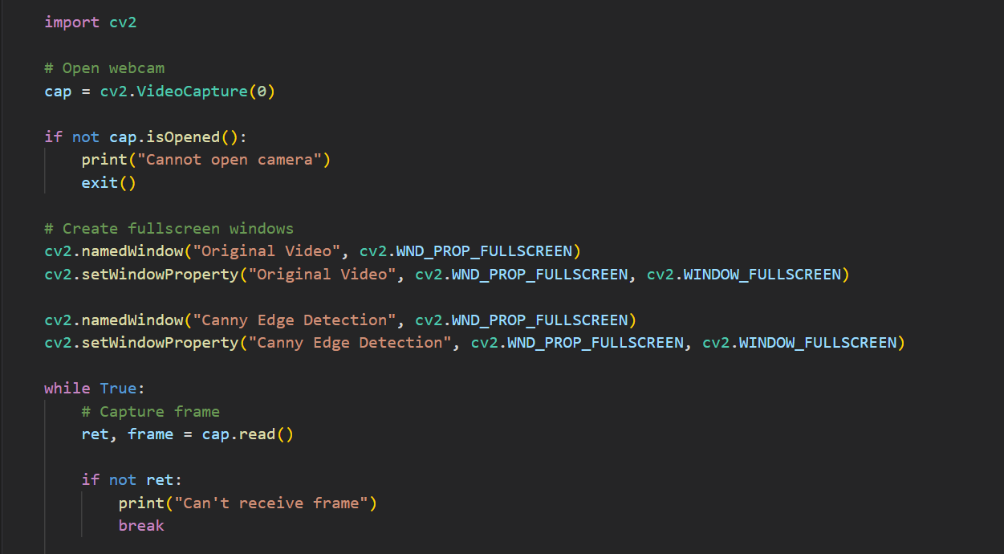
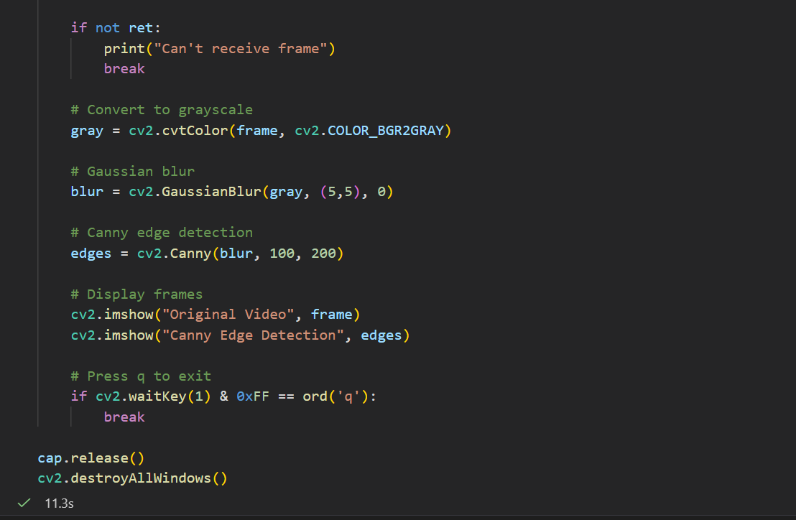

Output:
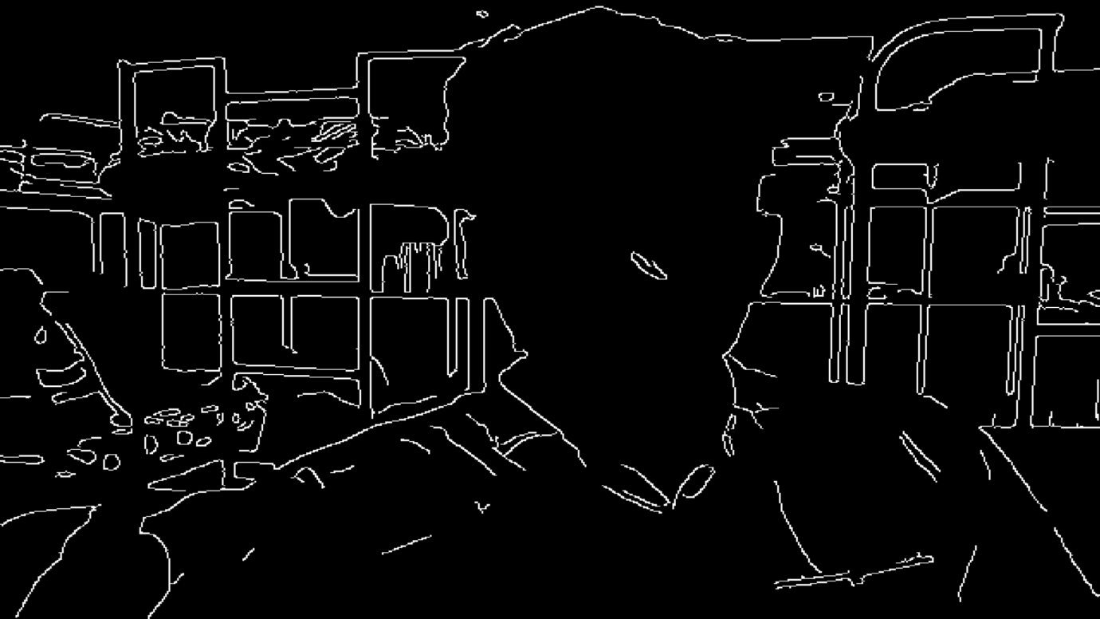

9.Converting Live video to Negative video:
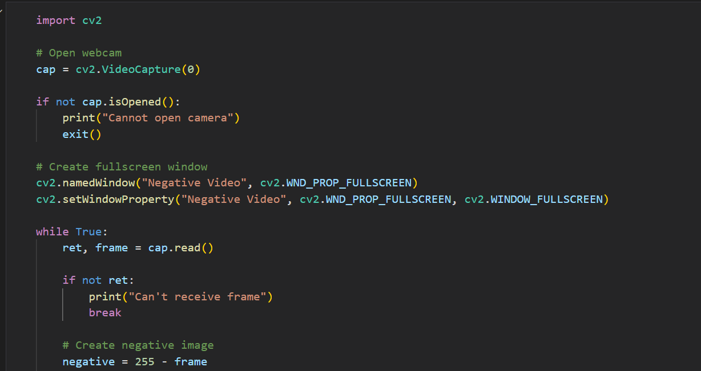

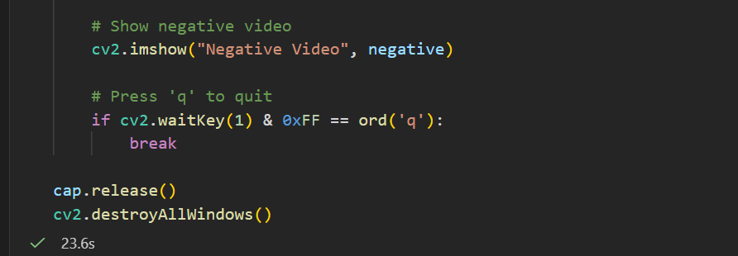
Output:
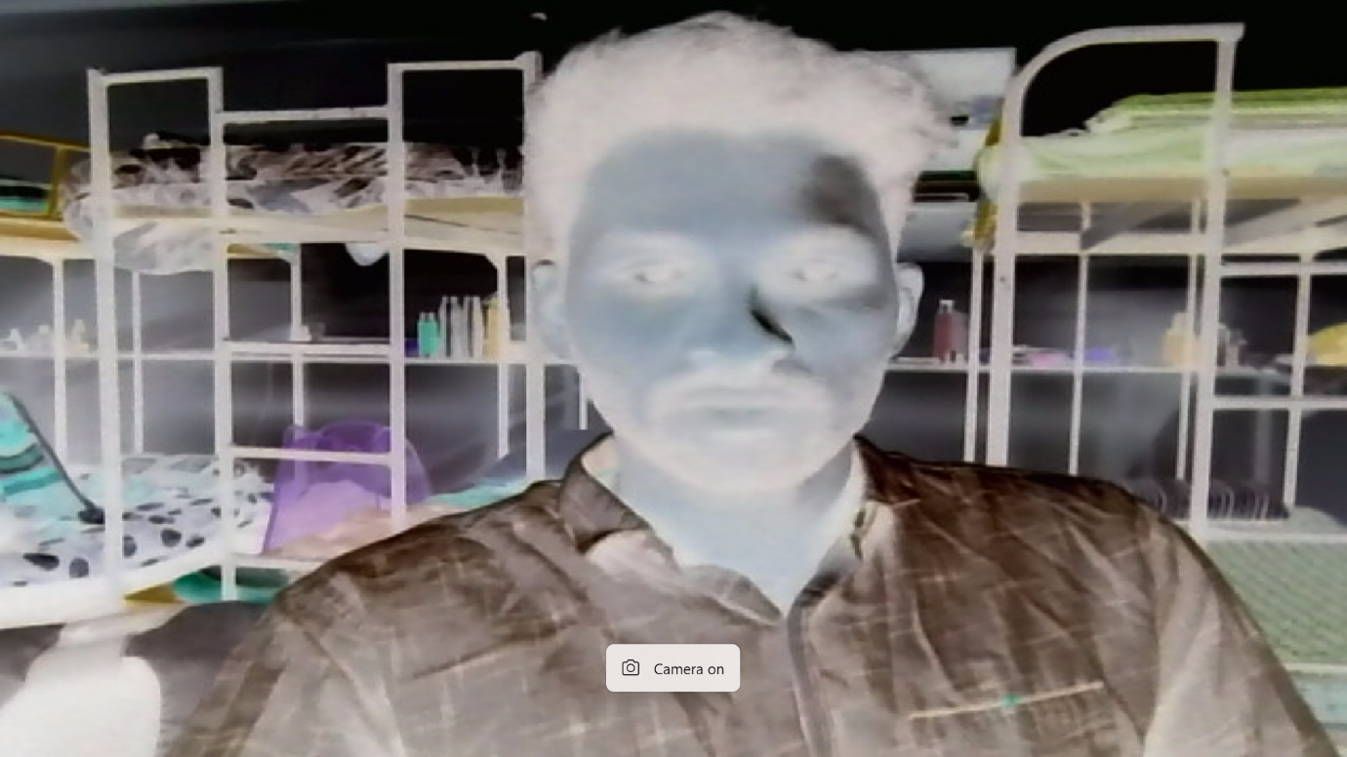
Mathematical Equation
For an 8-bit image:
$$s=255-r$$
Where:
- $r$= original pixel value
- $s$= negative pixel value
- 255 = maximum intensity value in an 8-bit image

10.Detecting the motion if motion found edge will be shown otherwise black screen will be shown.

Mathematical Equation:
1. Grayscale Conversion
$$Gray\left(x,y\right)=0.299R\left(x,y\right)+0.587G\left(x,y\right)+0.114B\left(x,y\right)$$
2. Frame Difference (Motion Detection):
$D\left(x,y\right)=\left|G_{t}\left(x,y\right)-G_{t-1}\left(x,y\right)\right|$

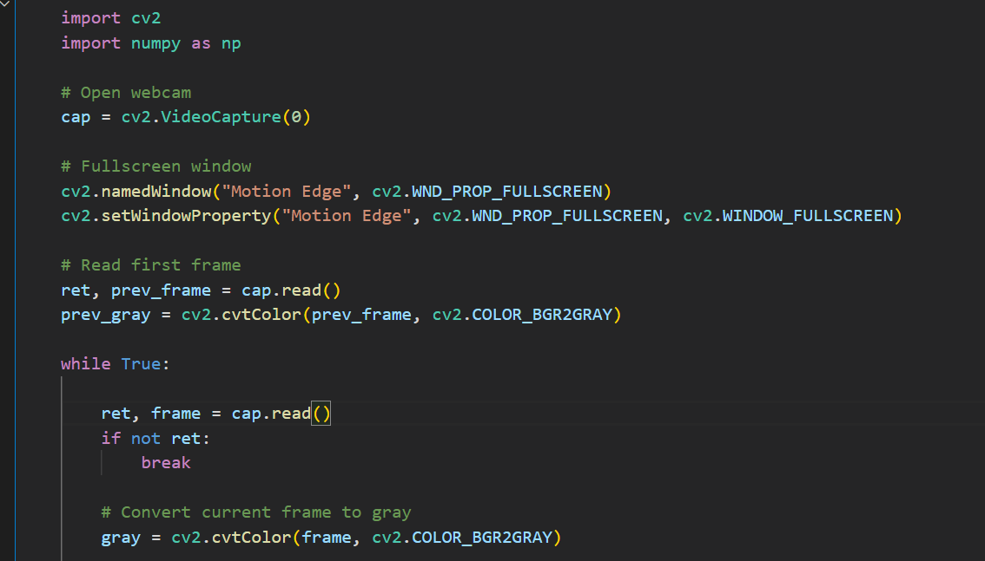

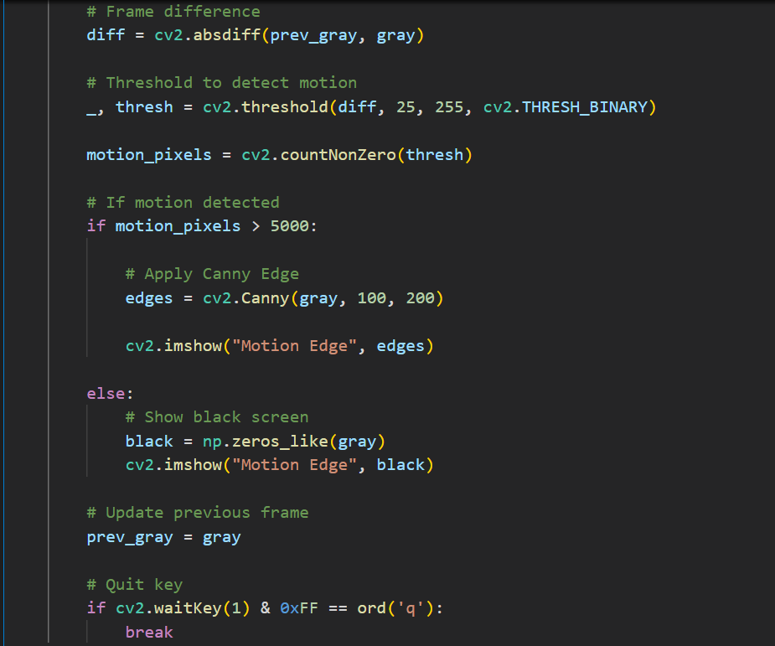

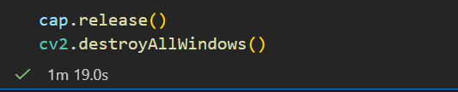

Output:
Drive Output

